Variable Resource Charging

Set Tab A to be one rate

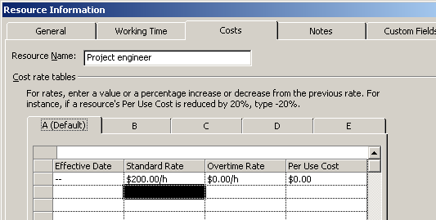

Set Tab B to be a different rate
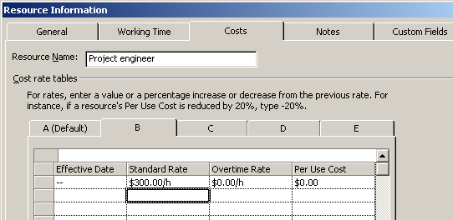

Select the “Resource Usage” View and change the Table displayed in this View to be the “Cost” table.

Insert a New Column in to the Table – in the Column Definition dialogue box chose the “Cost Rate Table”

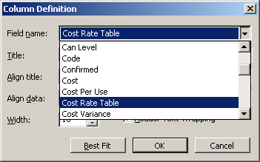

Your resource usage view will now show as below.

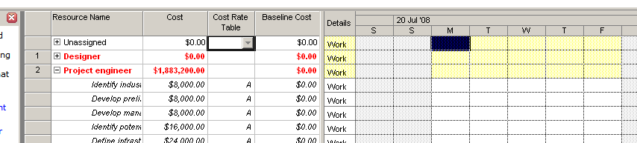

To change the Cost Rate Table for the Resource simply change all the values from A to B. If you are doing this for all resources in the project do the following.

Make sure all assignments are visible in the Resource Usage View – do this by left clicking once on the “Resource Name” column and then click the Show Assignments button to expand out all assignments for all resources in the plan.

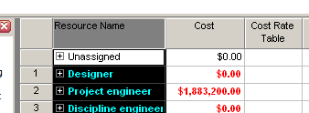

Now go to the Edit Menu and select the Replace option and elect to replace A with B in the Cost Rate Table field and then select “Replace All”

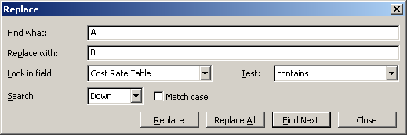

The example below shows the results of this action – the cost at the Project Engineer level is now $2,824,800.00 based on a cost rate of $300/h whereas the cost before of $1,883,200.00 was based on a cost rate of $200/h – the difference in these 2 figures is that B is 50% higher represents the cost differential correctly.

